**Daily Scrum or Standup Meeting**

Team name: ______TEAM 4___________________

Scrum Master: ______ Sterling Tolley_________

Date:___________11/4/19____________________

|  |  |  |  |
| --- | --- | --- | --- |
| **Team Member** | **What did you do since the last scrum?** | **What do you plan to do before the next scrum?** | **What obstacles do you have?** |
| Carter Figgins | Worked on live items and items bided on. | Figure out unit testing, Connect bid confirmation with items, and finish user bided list | Unit Testing |
| Brock Francom | Added css to itemviews and itemlistviews, and got the images to work. | Add the functionality to place a bid | Knowing how to place a bid. |
| Waseca Hodson | N/A | N/A | N/A |
| Sterling Tolley | Began working on user/admin access levels and registration page. | Finish registration and user authentication. |  |
|  |  |  |  |

# Burndown

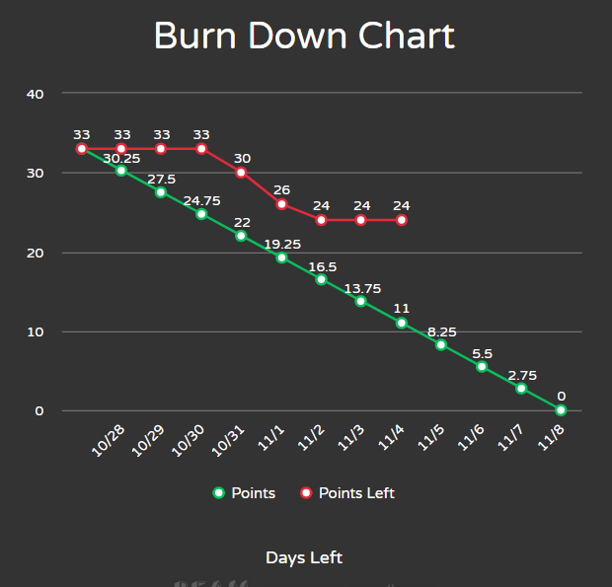

# Screenshot of you project board

